ASSIGNMENT#1

HUMAN COMPUTER INTERACTION

PACT ANALYSIS

CAR INFOTAINMENT SYSTEM (CIS)

Syndicate:

NC RAJA ANEEQ ASHRAF

NC SAAD MASOOD

PC HUMZA AAMIR

COURSE: BESE-16 A

DATE: 19th March 2012

**Introduction**

**CIS** is a computer system which is used to control most secondary vehicle systems in many upmarket cars. **CIS**'s user interface consists of a LCD panel mounted in the dashboard and a controller knob mounted on the center console. **CIS** allows the driver and front-seat passenger (in recent cars it is available to back-seat passengers as well) to control such amenities as the climate (air conditioner and heater), the audio system (radio and CD player), the navigation system and communication system.

The control element was developed according to the most modern biometric principles. It’s easy to use and can be operated with one hand without needing to see what you’re doing. The four most frequently used functions (CD, radio, telephone and navigation) are assigned to buttons above the Controller. An additional eight buttons located underneath the CD/DVD can be programmed as desired – be it with your favorite radio station, CD titles, telephone numbers or destinations. **CIS** is equipped with voice control for an even more comfortable input option.

The height and width of the Control Display are optimally positioned to suit the driver. All the information is displayed in the glare-free, high-resolution screen above the central console. The menu navigation follows the standard method used in computing and can thus be used intuitively. Animations and other visual aids quickly make using **CIS** a pleasant everyday activity.

**CIS** is the easiest and most intuitive way to control entertainment, information, communication and navigation functions. The goal is to separate display and steering. The system mainly comprises the Control Display and the Controller in the central console.

__________________________________________________

**Aim**

**CIS** is aimed at car manufacturers who desire to give their customer a luxurious in-car environment. Keep track of all the important things. The **CIS** system gives the driver complete control over many of the vehicle’s functions while allowing him to concentrate on the road.

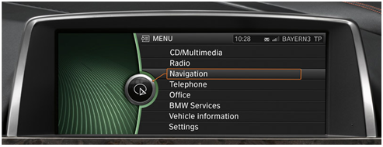 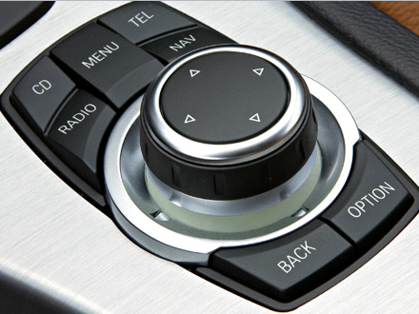

**Control Display Control Knob**

**Proposed CIS Main Interface**

**PACT ANALYSIS**

***PEOPLE:***

* The primary customers for **CIS** are people who demand a simple and elegant software interface which gives them authority over critical functions and entertainment features such as driving mode, music, engine and suspension configuration etc.

* Companies who buy cars in fleet for facilitating their employees. These cars may be included in a job package (considerably highly paid) or reserved for high end people such as CEOs and Directors of the company.
* ***Physical Difference***
* No physical differences exist because certain criteria have to be met to operate a car and this system. Medically unfit people such as blind, deaf and disabled as well as mentally abnormal are not illegible to use **CIS**.
* ***Psychological Difference***

**CIS** is aimed at a global market. Due to psychological differences among the target people, following parameters have been considered.

* **Language**

To deal with language problems, **CIS** is available in ENGLISH, ARABIC, URDU, CHINESE and GERMAN language.

* **Spatial Ability**

People with varying receptive and problem solving skills, both can accomplish the same task easily such as choosing a destination on the navigation menu because the interface is very simple and easy to use.

* **Recognition Vs. Memorization:**

Frequent tasks such as listening to music or tuning FM fall in the recognition category where as rare events such as configuring the engine falls in the memorization category. For activities involving recognition, the elegantly designed interface helps the user to solve frequent tasks. For infrequent activities, demos and help menus assist the user.

* ***Usage difference***
* People just considered with the job of getting from point A to B are novice users to the system. People who want to customize the response of the car and fully utilize **CIS** are expert users. **CIS** offers a friendly environment to both the categories allowing for a great driving experience.

***ACTIVITIES:***

The activities fall in four categories and **CIS** is designed to handle each of them.

* ***Temporal***

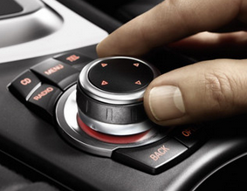Frequent activities such as playing cd, tuning radio or telephone are assigned buttons on controller knob for quick access. Infrequent activities like suspension configuration are accessed deep within the system to avoid accidental use.

* ***Safety Critical***

The system alerts the user if any the following events occur:



|  |  |
| --- | --- |
| **Event** | **System Response** |
| Unsuitable Engine Configuration | Option to restore default system settings. |
| Drowsiness of driver | Beep is generated to alert the driver. |
| Crossing Speed Limit | Warns to reduce car speed. |

* ***Nature of data***

Following data types are handled by CIS:

|  |  |  |
| --- | --- | --- |
| **Data Type** | **Figure** | **Example** |
| Voice Data |  | Optional communication format with system. |
| Alphanumeric Data |  | Entering addresses or telephone numbers etc. |

* ***Seven Stages of User Activity***

The figure below represents the different phases the user will go through when he wants to reach a destination using the car’s GPS system.



FORMING INTENTION:

LOCATE POINT B ON MAP

EVALUATION:

CHECK MAP ACCURACY

IS ROUTE CORRECT?

INTERPRETATION:

THE MAP IS GUIDING TOWARDS POINT B

ACTION:

USING MENUS AND SUB-MENUS TO LOCATE POINT B

EXECUTION:

SELECTING POINT B AND RECEVING CO-ORDINATES

PERCEPTION:

GPS MAP IS DISPLAYED ON THE SCREEN

CIS SYSTEM

***CONTEXT:***

* ***Physical***

The context of this system is a typical car interior environment. The LCD panel for the **CIS** screen is positioned as such to avoid glare and direct sunlight. The control knob is placed at a comfortable position and the ergonomics have been fine tuned for a smooth operating environment. The screen is placed at a decent distance from the driver; it does not hinder any forward vision or block usage space. It is located in the purpose built panel on the dashboard.

* ***Social***

The GPS system contains the real-time position of the car and therefore can be a privacy concern for the user. The **CIS** system provides fool proof security against leakage of information or sharing the location to any third party software. Socially, the users we're considering are the closest to experts on the system, and so needs little help. Never the less, a complete HELP guide is included in the menu for any kind of assistance.

* ***Organization***

The CIS system is developed for the automobile industry. It is dependent upon the car manufacturers and their business. Due to the ever increasing involvement and use of computer and technology in daily lives, the car companies want their customers to experience this type of environment in their vehicles. The **CIS** system provides a high tech digital multimedia user application for controlling various features of the car.

***TECHNOLOGY:***

Following technology has been utilized for:

* ***INPUT***

**ROTATORY KNOB** input.

**CAPACITIVE TOUCHSCREEN** for user input.

**VOICE RECOGNITION** for interacting with **CIS.**

* ***OUTPUT***

**LCD PANEL** displaying menus.

**VOICE OUTPUT** for guiding in GPS maps.

**MEDIA PLAYERS** for audio and video entertainment.

**HARDDISK** for storing user records such as playlists and favorite FM channels etc.

* ***COMMUNICATION***

**GPS tracking** for route navigation.

**SIM CARD** using **GSM** technology.

________________________________________________________________________